Wi-Fi NIC

📶 What is a Wi-Fi NIC (Network Interface Card)?
# Source: AI Source: Provided by: [Data Path: Persons Table -> ID Column: 1, Name_En Column: Motasem Essam] -> From: [ChatGPT] on [12/18/2025]
A Wi-Fi NIC (also called a Wireless NIC or WLAN card) is a hardware component that allows a computer, laptop, smartphone, or any digital device to connect wirelessly to a Wi-Fi network. It uses radio signals instead of physical cables to communicate with wireless access points (routers).
✅ A Wi-Fi NIC is your device’s wireless gateway to the internet or LAN — no Ethernet cables required.

🔧 What Does a Wi-Fi NIC Do?
# Source: AI Source: Provided by: [Data Path: Persons Table -> ID Column: 1, Name_En Column: Motasem Essam] -> From: [ChatGPT] on [12/18/2025]
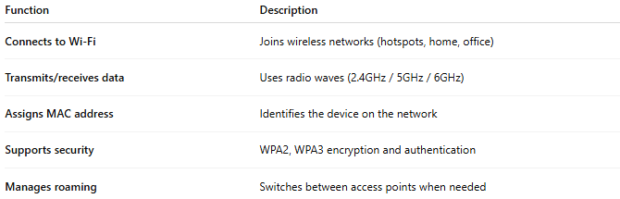
Function | Description
Connects to Wi-Fi | Joins wireless networks (hotspots, home, office)
Transmits/receives data | Uses radio waves (2.4GHz / 5GHz / 6GHz)
Assigns MAC address | Identifies the device on the network
Supports security | WPA2, WPA3 encryption and authentication
Manages roaming | Switches between access points when needed

📦 Types of Wi-Fi NICs
# Source: AI Source: Provided by: [Data Path: Persons Table -> ID Column: 1, Name_En Column: Motasem Essam] -> From: [ChatGPT] on [12/18/2025]
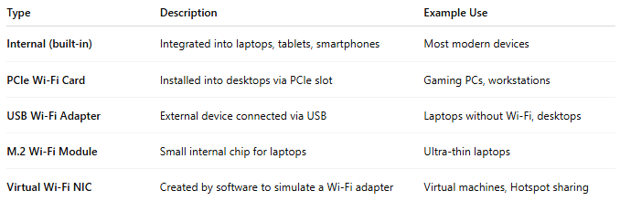
Type | Description | Example Use
Internal (built-in) | Integrated into laptops, tablets, smartphones | Most modern devices
PCIe Wi-Fi Card | Installed into desktops via PCIe slot | Gaming PCs, workstations
USB Wi-Fi Adapter | External device connected via USB | Laptops without Wi-Fi, desktops
M.2 Wi-Fi Module | Small internal chip for laptops | Ultra-thin laptops
Virtual Wi-Fi NIC | Created by software to simulate a Wi-Fi adapter | Virtual machines, Hotspot sharing

📡 Wi-Fi Bands & Standards
# Source: AI Source: Provided by: [Data Path: Persons Table -> ID Column: 1, Name_En Column: Motasem Essam] -> From: [ChatGPT] on [12/18/2025]
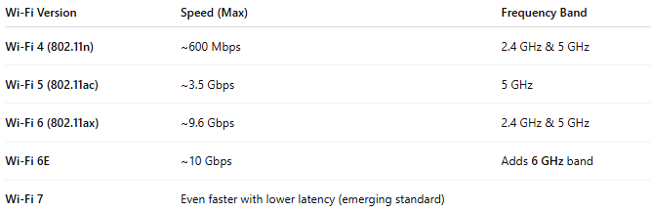
Wi-Fi Version | Speed (Max) | Frequency Band
Wi-Fi 4 (802.11n) | ~600 Mbps | 2.4 GHz & 5 GHz
Wi-Fi 5 (802.11ac) | ~3.5 Gbps | 5 GHz
Wi-Fi 6 (802.11ax) | ~9.6 Gbps | 2.4 GHz & 5 GHz
Wi-Fi 6E | ~10 Gbps | Adds 6 GHz band
Wi-Fi 7 | Even faster with lower latency (emerging standard)

✅ Advantages
# Source: AI Source: Provided by: [Data Path: Persons Table -> ID Column: 1, Name_En Column: Motasem Essam] -> From: [ChatGPT] on [12/18/2025]
- ✅ No cables needed — great for portability
- ✅ Supports mobility and flexible setup
- ✅ Easy installation, especially with USB adapters
- ✅ Works well for general internet, video calls, and streaming

❌ Disadvantages
# Source: AI Source: Provided by: [Data Path: Persons Table -> ID Column: 1, Name_En Column: Motasem Essam] -> From: [ChatGPT] on [12/18/2025]
- ❌ Slower than Ethernet in most cases
- ❌ Interference from walls, microwaves, and other networks
- ❌ Less stable for heavy gaming or file transfers
- ❌ Can drain more battery on laptops and mobile devices

🔍 Common Brands
# Source: AI Source: Provided by: [Data Path: Persons Table -> ID Column: 1, Name_En Column: Motasem Essam] -> From: [ChatGPT] on [12/18/2025]
- Intel (for laptops & M.2 cards)
- TP-Link, ASUS, Netgear (USB & PCIe adapters)
- Realtek, Broadcom, Qualcomm (chipset makers)

📌 Summary
# Source: AI Source: Provided by: [Data Path: Persons Table -> ID Column: 1, Name_En Column: Motasem Essam] -> From: [ChatGPT] on [12/18/2025]
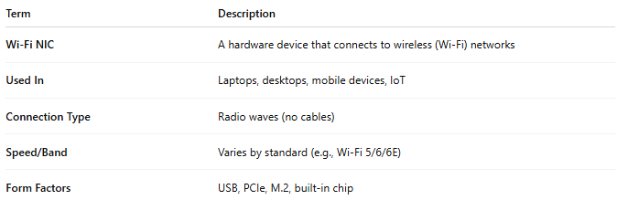
Term | Description
Wi-Fi NIC | A hardware device that connects to wireless (Wi-Fi) networks
Used In | Laptops, desktops, mobile devices, IoT
Connection Type | Radio waves (no cables)
Speed/Band | Varies by standard (e.g., Wi-Fi 5/6/6E)
Form Factors | USB, PCIe, M.2, built-in chip

